

FACULTY OF INFORMATION AND COMMUNICATION TECHNOLOGY

DCOMP 204 – WEB DESIGN 1

Title: Individual Assignment
Issue Date: Week 2
Due Date: Week 4
Lecturer/Examiner: MR. AMADU KAMARA
Name of Student/s: RODNEY MAK MASSAQUOI
Student ID No.: 905005324
Class: DIT1102
Semester/Year:1/2

Academic Honesty Policy Statement

I/We hereby attest those contents of this attachment are my own work. Referenced works, articles, art, programs, papers or parts thereof are acknowledged at the end of this paper. This includes data excerpted from CD-ROMs, the Internet, other private networks, and other people’s disk of the computer system.

Student’s Signature: Date: 18TH October, 2025
LECTURER’S COMMMENTS/GRADE:

forofficeuseonlyuponreceive
Remark

DATE:
TIME:
RECEIVER’SNAME:



FACULTY OF INFORMATION AND COMMUNICATION TECHNOLOGY

DCOMP 204 – WEB DESIGN 1

Title: Assignment 2: HTML & CSS Prototype
Issue Date: Week 5
Due Date: Week 7
Lecturer/Examiner: MR. AMADU KAMARA
Name of Student/s: RODNEY MAK MASSAQUOI
Student ID No.: 905005324
Class: DIT1102
Semester/Year:1/2

Academic Honesty Policy Statement

I/We hereby attest those contents of this attachment are my own work. Referenced works, articles, art, programs, papers or parts thereof are acknowledged at the end of this paper. This includes data excerpted from CD-ROMs, the Internet, other private networks, and other people’s disk of the computer system.

Student’s Signature: Date: 24TH November, 2025
LECTURER’S COMMMENTS/GRADE:

forofficeuseonlyuponreceive
Remark

DATE:
TIME:
RECEIVER’SNAME:

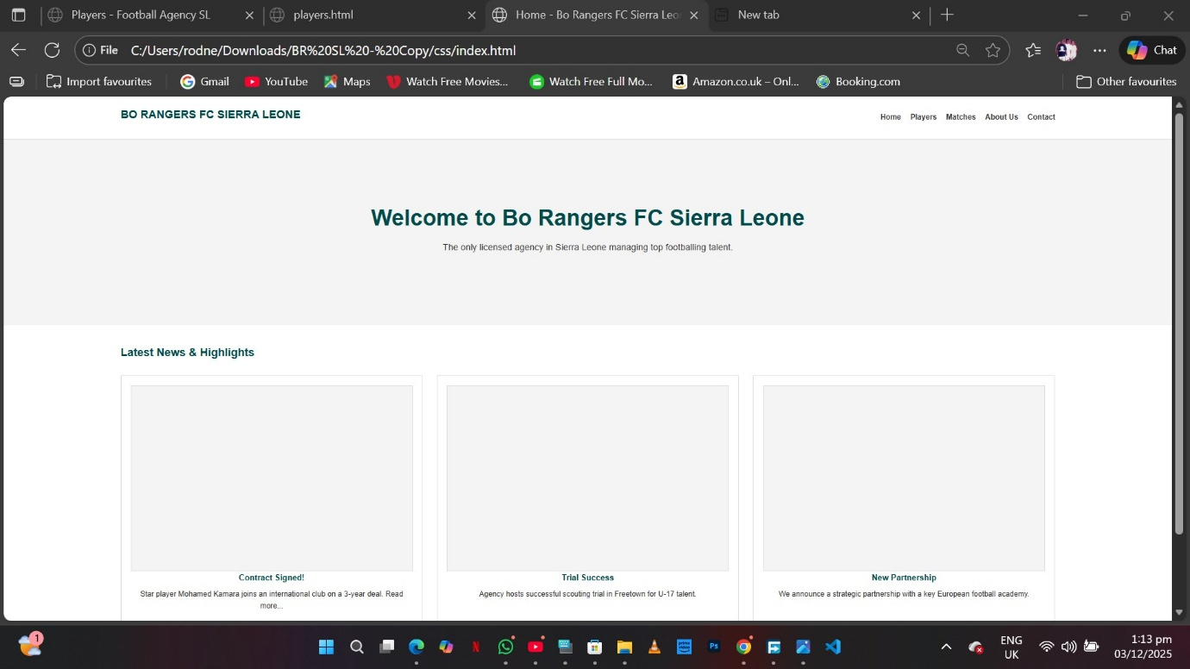
<!DOCTYPE html>
<html lang="en">
<head>
<meta charset="UTF-8">
<meta name="viewport" content="width=device-width, initial-scale=1.0">
<title>Home - Bo Rangers FC Sierra Leone</title>
<link rel="stylesheet" href="css/style.css">
</head>
<body>
<header>
<div class="container">
<h1><a href="index.html">Bo Rangers FC Sierra Leone</a></h1>
<nav>
<ul>
<li><a href="index.html">Home</a></li>
<li><a href="players.html">Players</a></li>
<li><a href="matches.html">Matches</a></li>
<li><a href="about.html">About Us</a></li>
<li><a href="contact.html">Contact</a></li>
</ul>
</nav>
</div>
</header>

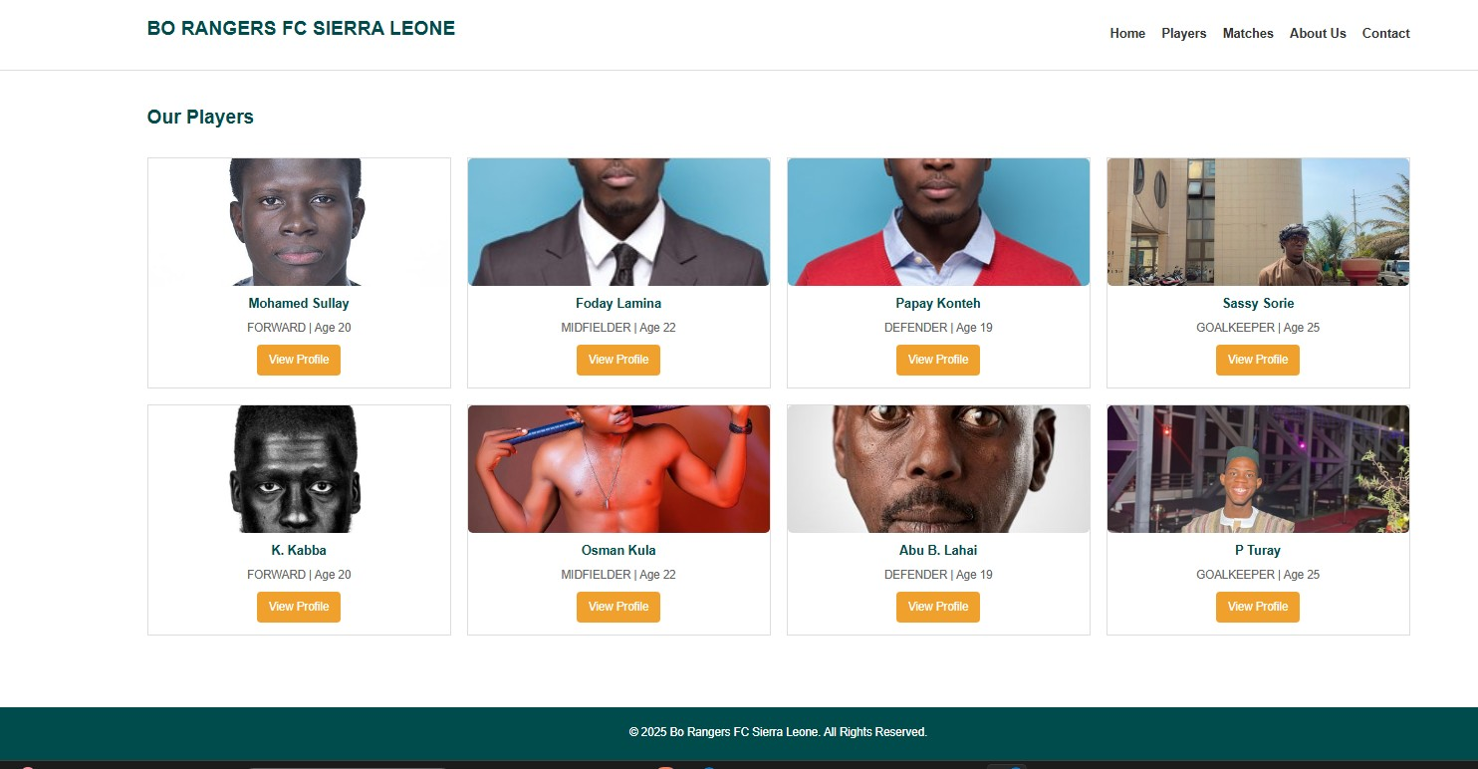
<!DOCTYPE html>
<html lang="en">
<head>
<meta charset="UTF-8">
<meta name="viewport" content="width=device-width, initial-scale=1.0">
<title>Players - Bo Rangers FC Sierra Leone</title>
<link rel="stylesheet" href="css/style.css">
</head>
<body>
<header>
<div class="container">
<h1><a href="index.html">Bo Rangers FC Sierra Leone</a></h1>
<nav>
<ul>
<li><a href="index.html">Home</a></li>
<li><a href="players.html">Players</a></li>
<li><a href="matches.html">Matches</a></li>
<li><a href="about.html">About Us</a></li>
<li><a href="contact.html">Contact</a></li>
</ul>
</nav>
</div>
</header>

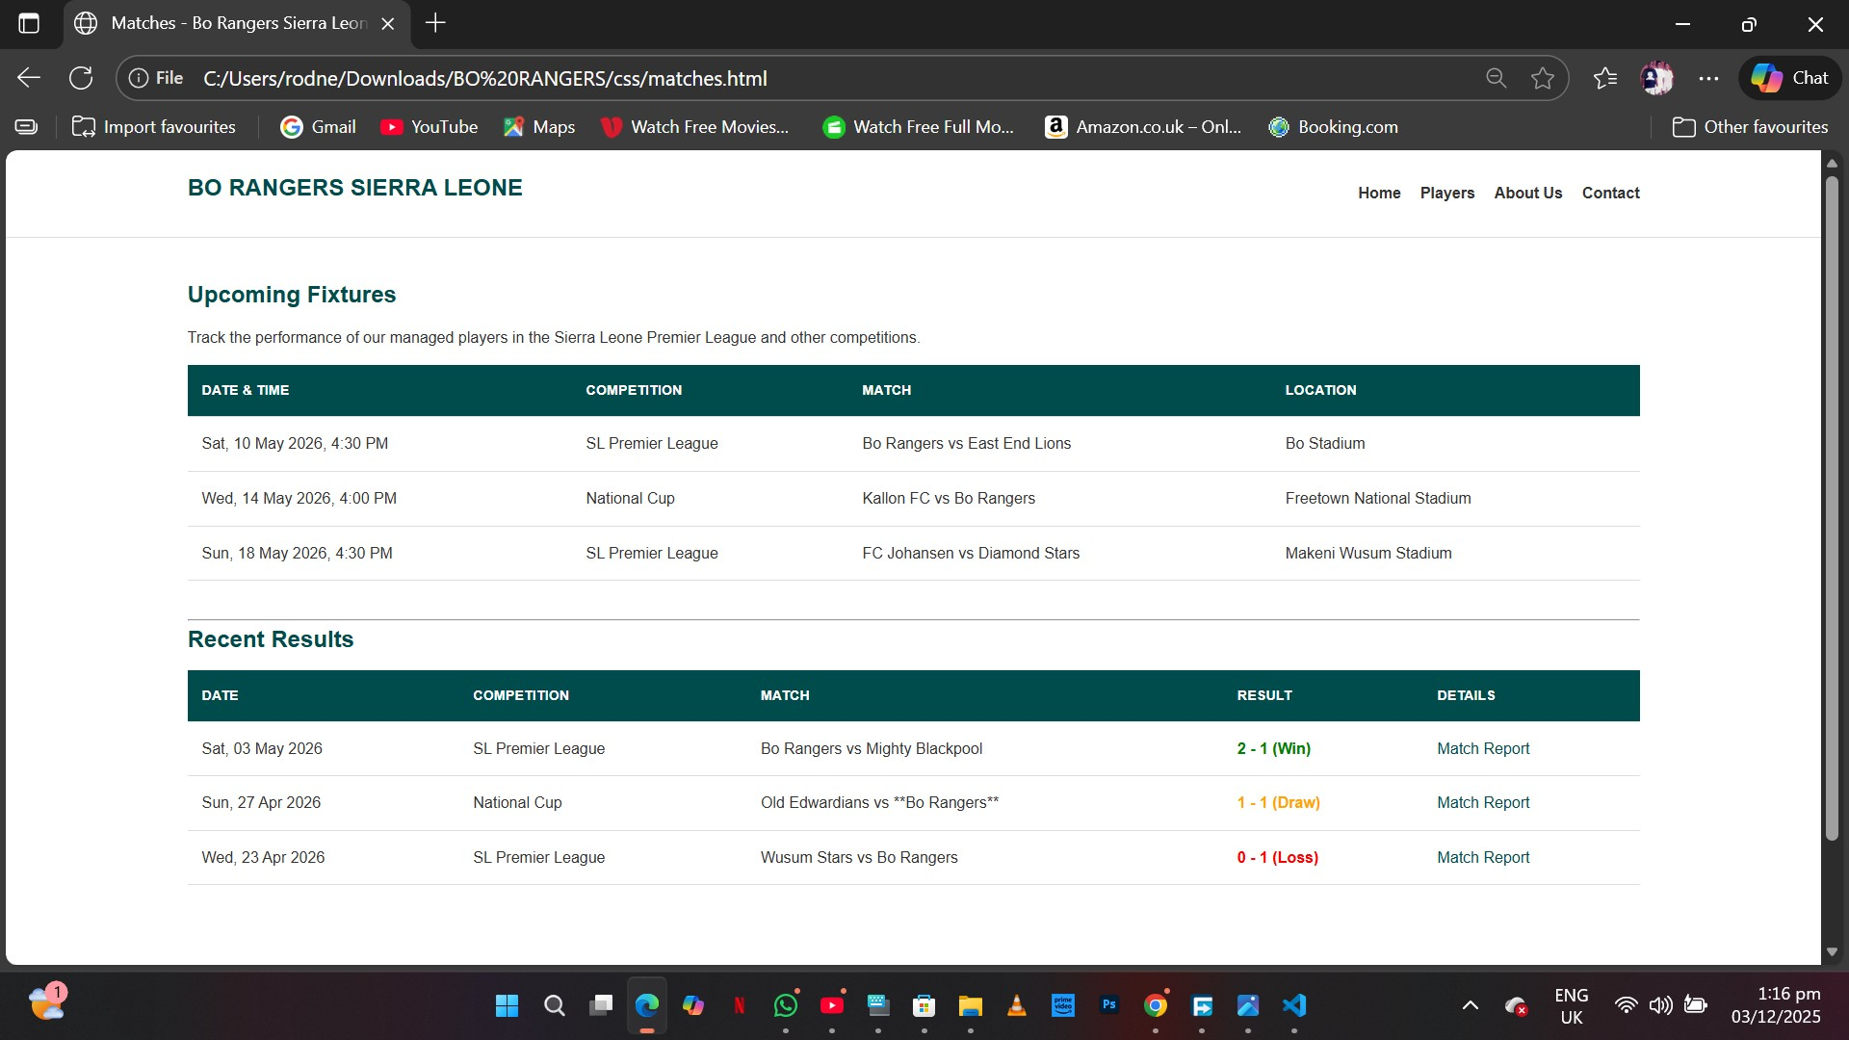
<!DOCTYPE html>
<html lang="en">
<head>
<meta charset="UTF-8">
<meta name="viewport" content="width=device-width, initial-scale=1.0">
<title>About Us - Bo Rangers FC Sierra Leone</title>
<link rel="stylesheet" href="css/style.css">
</head>
<body>
<header>
<div class="container">
<h1><a href="index.html">Bo Rangers FC Sierra Leone</a></h1>
<nav>
<ul>
<li><a href="index.html">Home</a></li>
<li><a href="players.html">Players</a></li>
<li><a href="matches.html">Matches</a></li>
<li><a href="about.html">About Us</a></li>
<li><a href="contact.html">Contact</a></li>
</ul>
</nav>
</div>
</header>

